– Assignment
Objective
The objective of this project was to set up a remote Linux server and configure secure SSH access using multiple SSH key pairs. Additionally, a basic security layer was implemented using Fail2Ban to protect against brute-force attacks.

Steps Performed
1. Server Setup
- Created a remote Linux server using a cloud provider (Ubuntu instance).
- Connected to the server using the default SSH access provided.

2. SSH Key Generation
- Generated two SSH key pairs on the local machine:
ssh-keygen -t rsa -b 4096 -f ~/.ssh/devops_key1
ssh-keygen -t rsa -b 4096 -f ~/.ssh/devops_key2
- This created:
  - Private keys: devops_key1, devops_key2
  - Public keys: devops_key1.pub, devops_key2.pub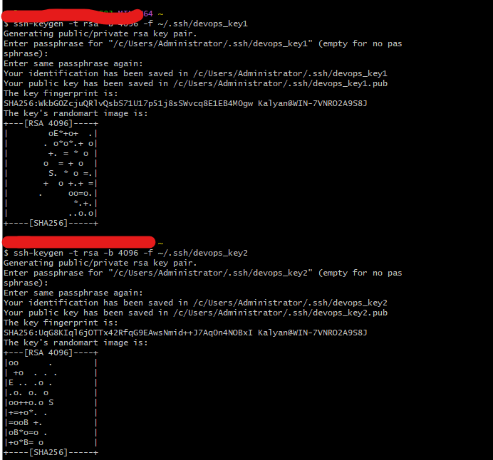

3. Configuring SSH Access
- Added both public keys to the server:
nano ~/.ssh/authorized_keys
- Pasted both public keys into the file (each on a new line).

4. Setting Permissions
- Applied correct permissions for SSH security:
chmod 700 ~/.ssh
chmod 600 ~/.ssh/authorized_keys

5. Testing SSH Access
- Verified access using both keys:
ssh -i ~/.ssh/devops_key1 ubuntu@<server-ip>
ssh -i ~/.ssh/devops_key2 ubuntu@<server-ip>
- Successfully connected using both SSH keys.

6. SSH Config Alias Setup
- Created SSH aliases for easier access:
nano ~/.ssh/config
- Added:
Host myserver-key1
HostName <server-ip>
User ubuntu
IdentityFile ~/.ssh/devops_key1

Host myserver-key2
HostName <server-ip>
User ubuntu
IdentityFile ~/.ssh/devops_key2
- Now able to connect using:
ssh myserver-key1
ssh myserver-key2
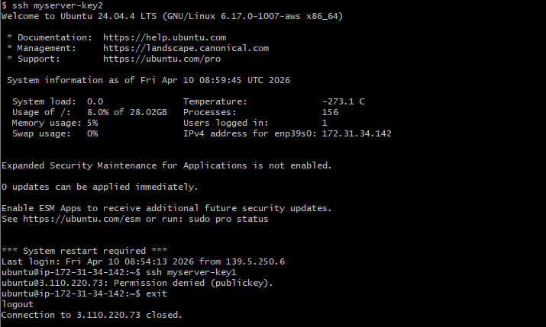
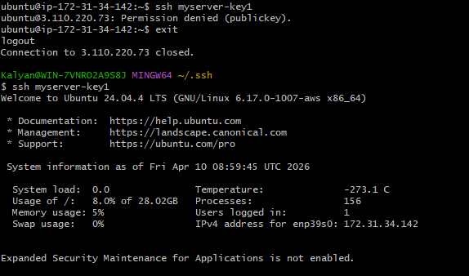
Stretch Goal: Fail2Ban Setup
- Installed Fail2Ban:
sudo apt update
sudo apt install fail2ban -y
- Enabled and started the service:
sudo systemctl enable fail2ban
sudo systemctl start fail2ban
- Verified status:
sudo systemctl status fail2ban
- Fail2Ban helps prevent brute-force attacks by blocking IPs after repeated failed login attempts. 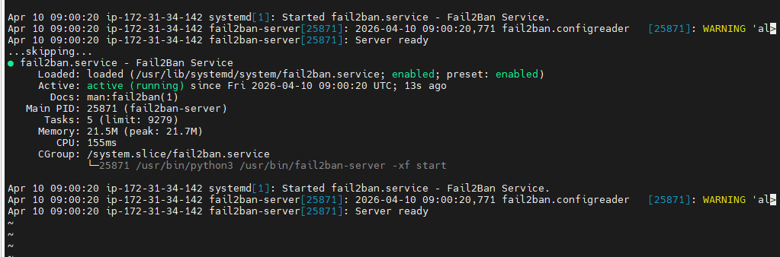

Outcome
- Successfully configured a remote Linux server.
- Enabled SSH access using multiple key pairs.
- Simplified access using SSH config aliases.
- Improved server security using Fail2Ban.

Conclusion
This project provided hands-on experience with:
- Linux server management
- SSH authentication
- Key-based access control
- Basic server security practices
These are fundamental skills required for DevOps and system administration roles.

